AGE 21+ / Research Verification Page: VERY IMPORTANT
Replicate like AMINO but in same theme as my company; Moving background Vials
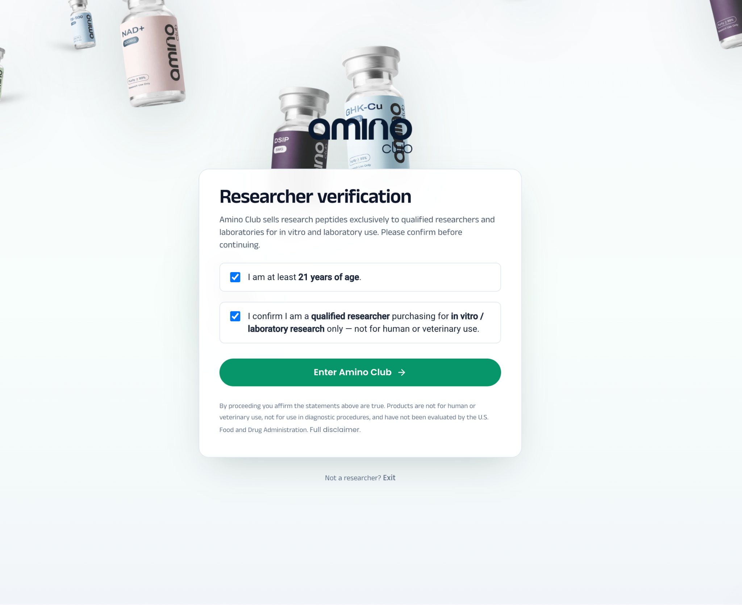

Header
Logo should take home!!
Home // Products // COA // About Us // FAQ // Contact Us

The Moving Header should contain:
Research Use Only Peptides - Iso 17025 Tested // Secure Checkout - Encrypted // Fast 2-Day Shipping - Free On Orders Over $175
As you can see on the Peptora site there is the moving header.
The top need to move and follow as they scroll down


Mobile should slide out like this and be…
Home // Products // COA // About Us // Contact Us // Membership
Insert line (like amino) and have below that My Account // Cart
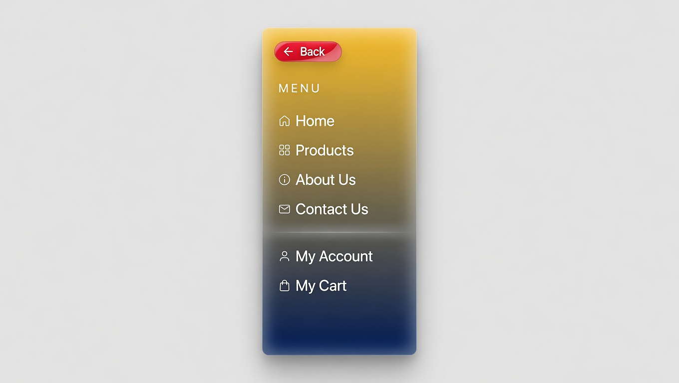

Home Page…
This is the most important part of the project…This is what the first scroll should look like…
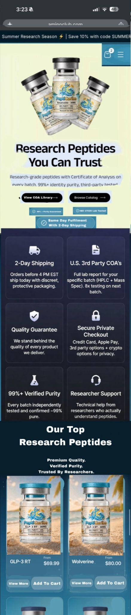

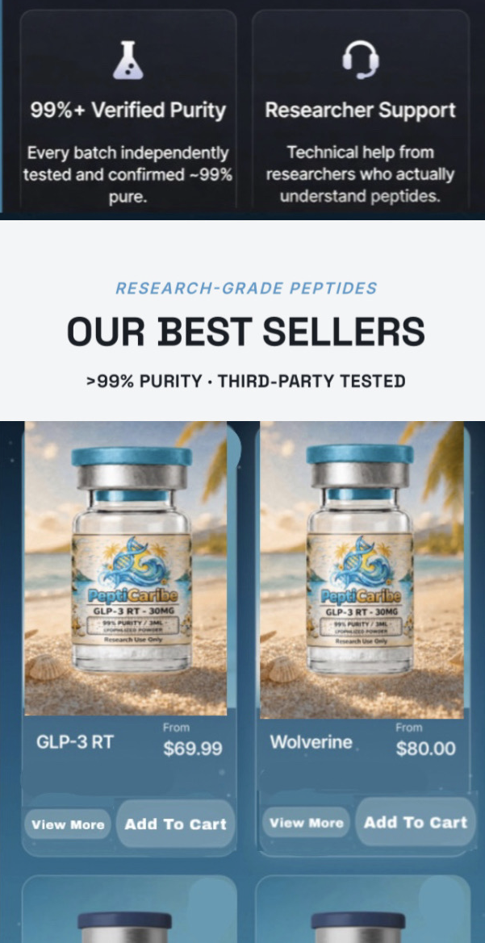

Products Page…
When the customer clicks the product page I would like it to say that at the top (limit the amount of space) and then for one product you can place the product image and for the other product you can place the AI Video. Alternate it as they scroll. One on left one on right etc.
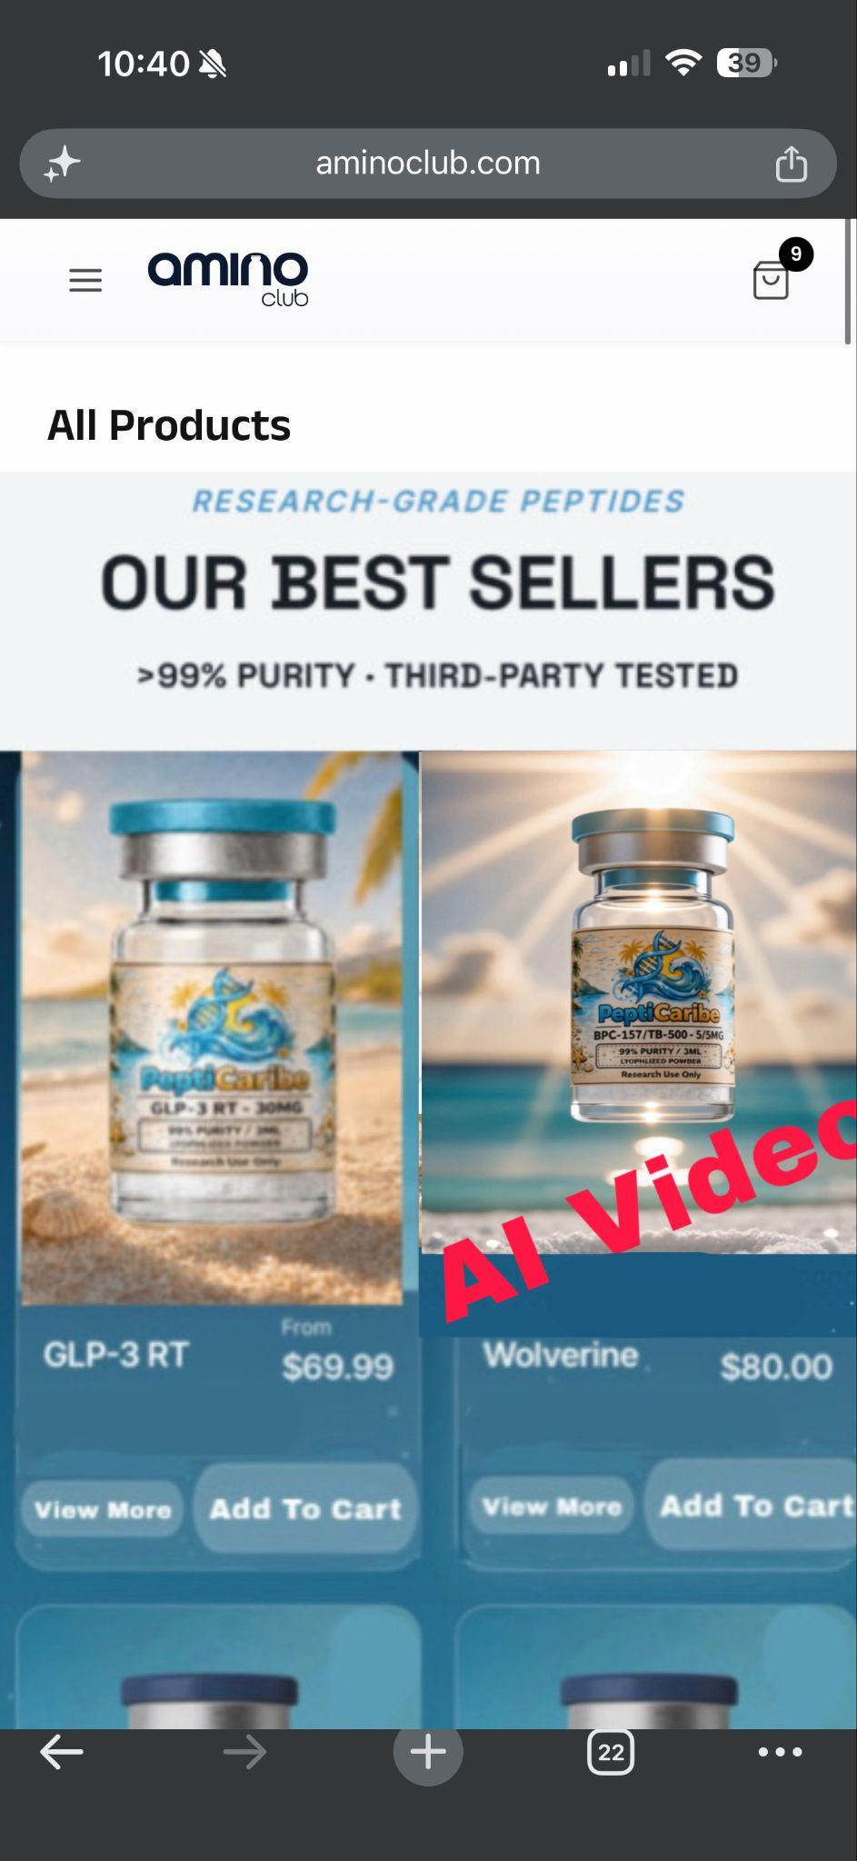

Product Page…
When a customer clicks on a specific product this is what it should look like.
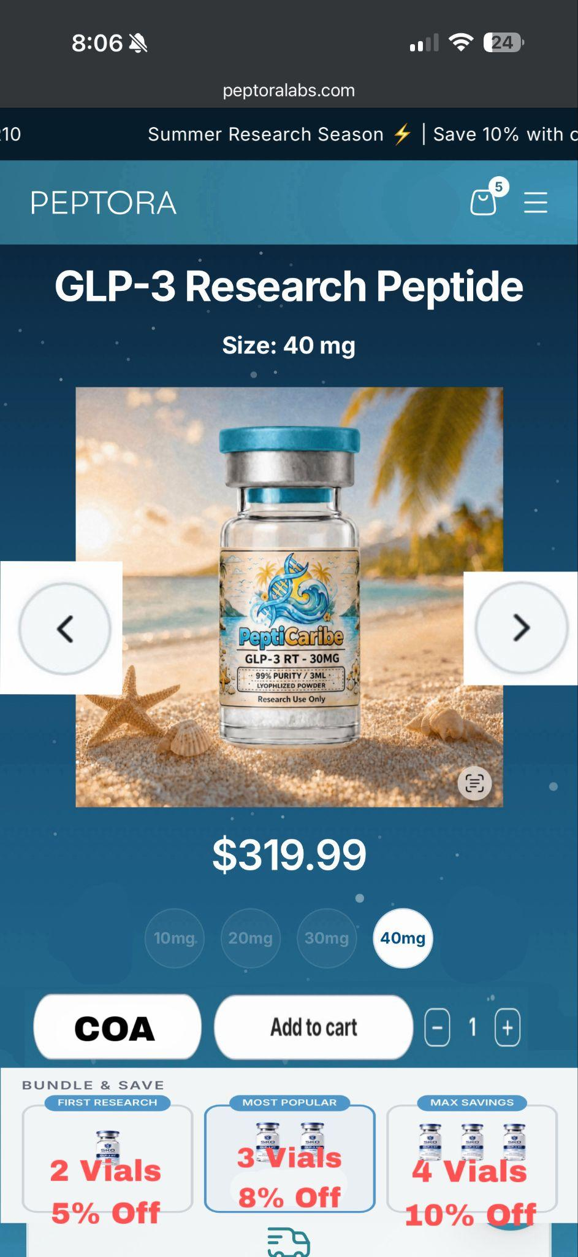
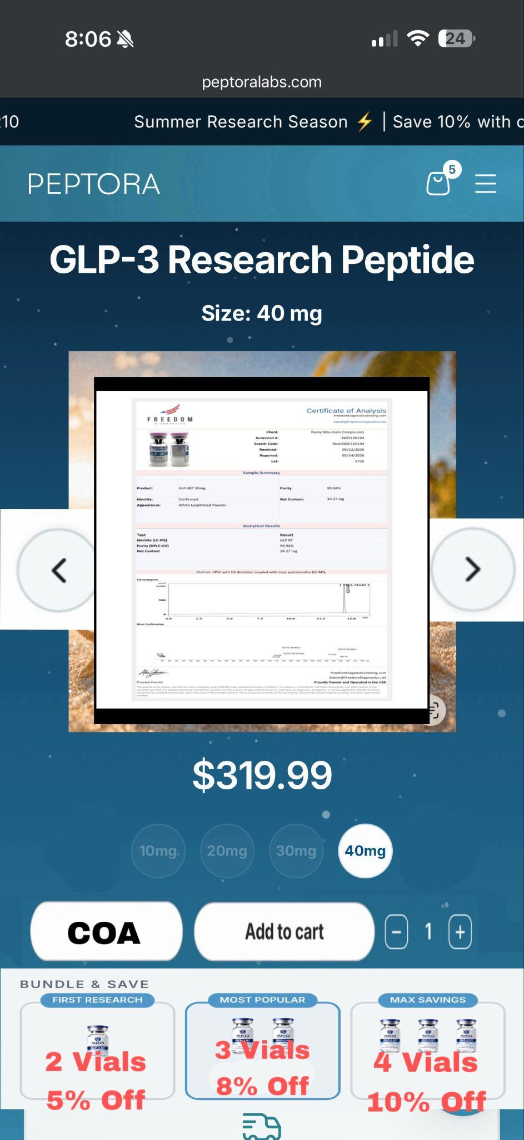
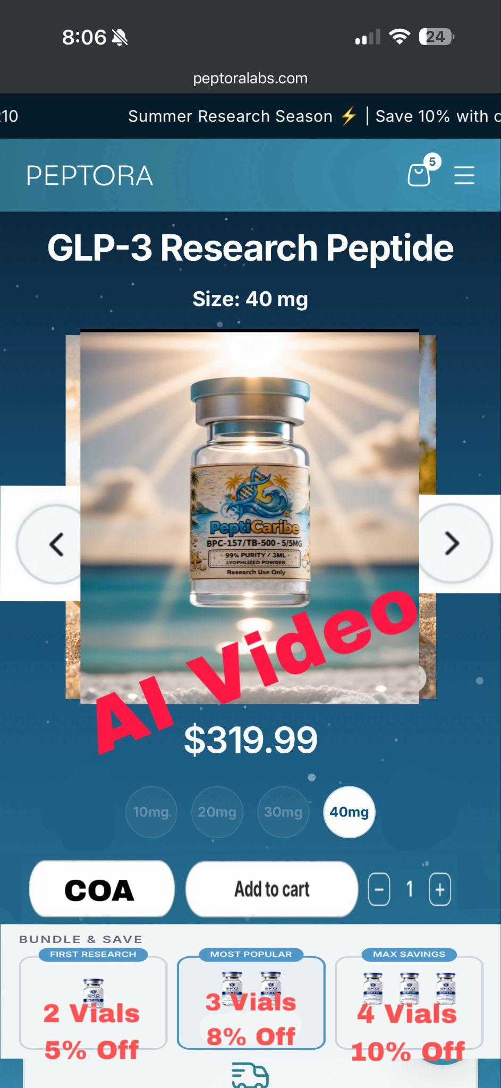

^^^^This is the Product landing Page, The other 2 pages to the right are what would show up next when they click the arrow, which would be the test results (Tap to expand and make bigger), then the AI Video.^^^^ Have an option for them to download the PDF as shown here… The pop-up should look like this…

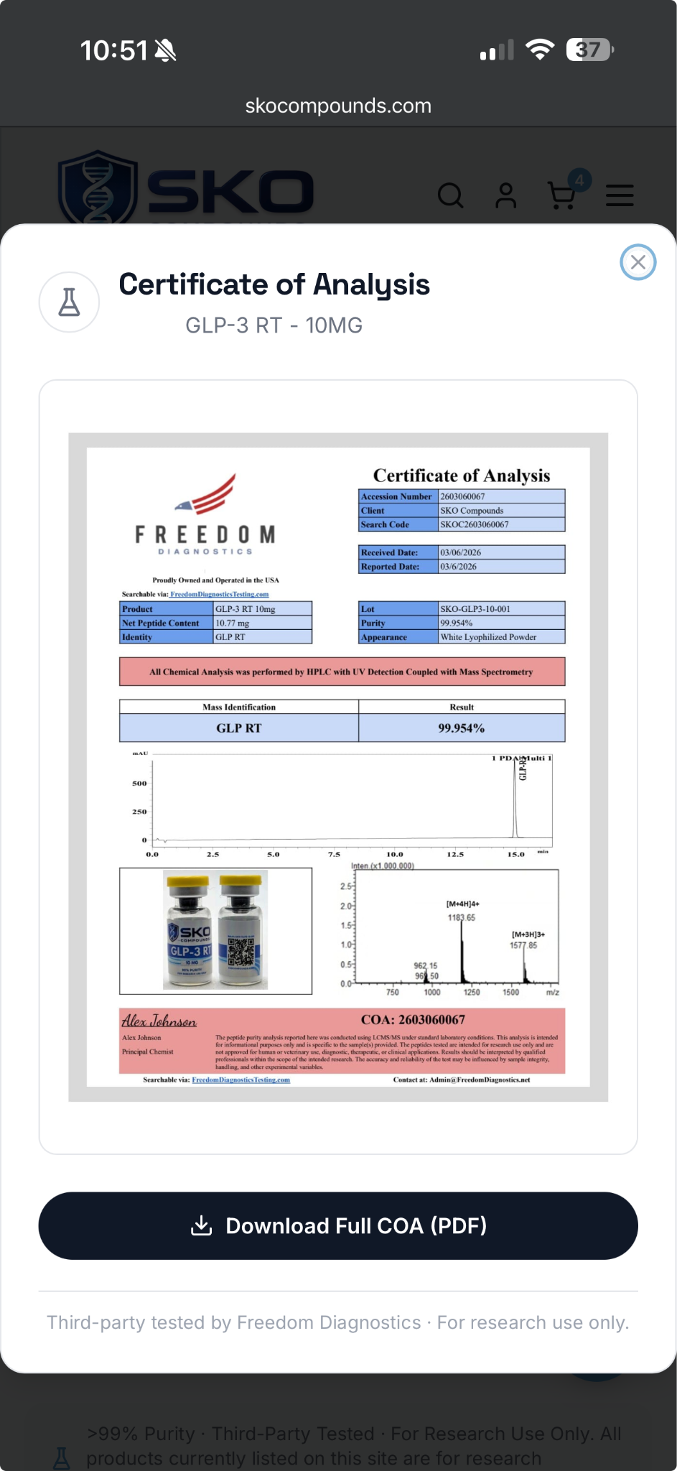
Product Page…
This is what is below each product for each of their pages

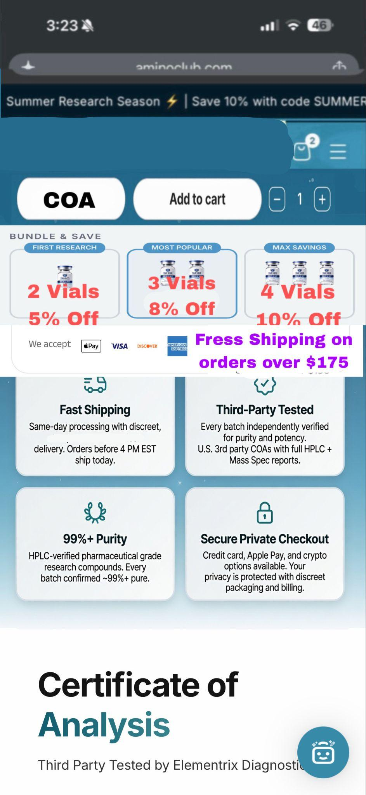

Keep Scrolling…You get to this…

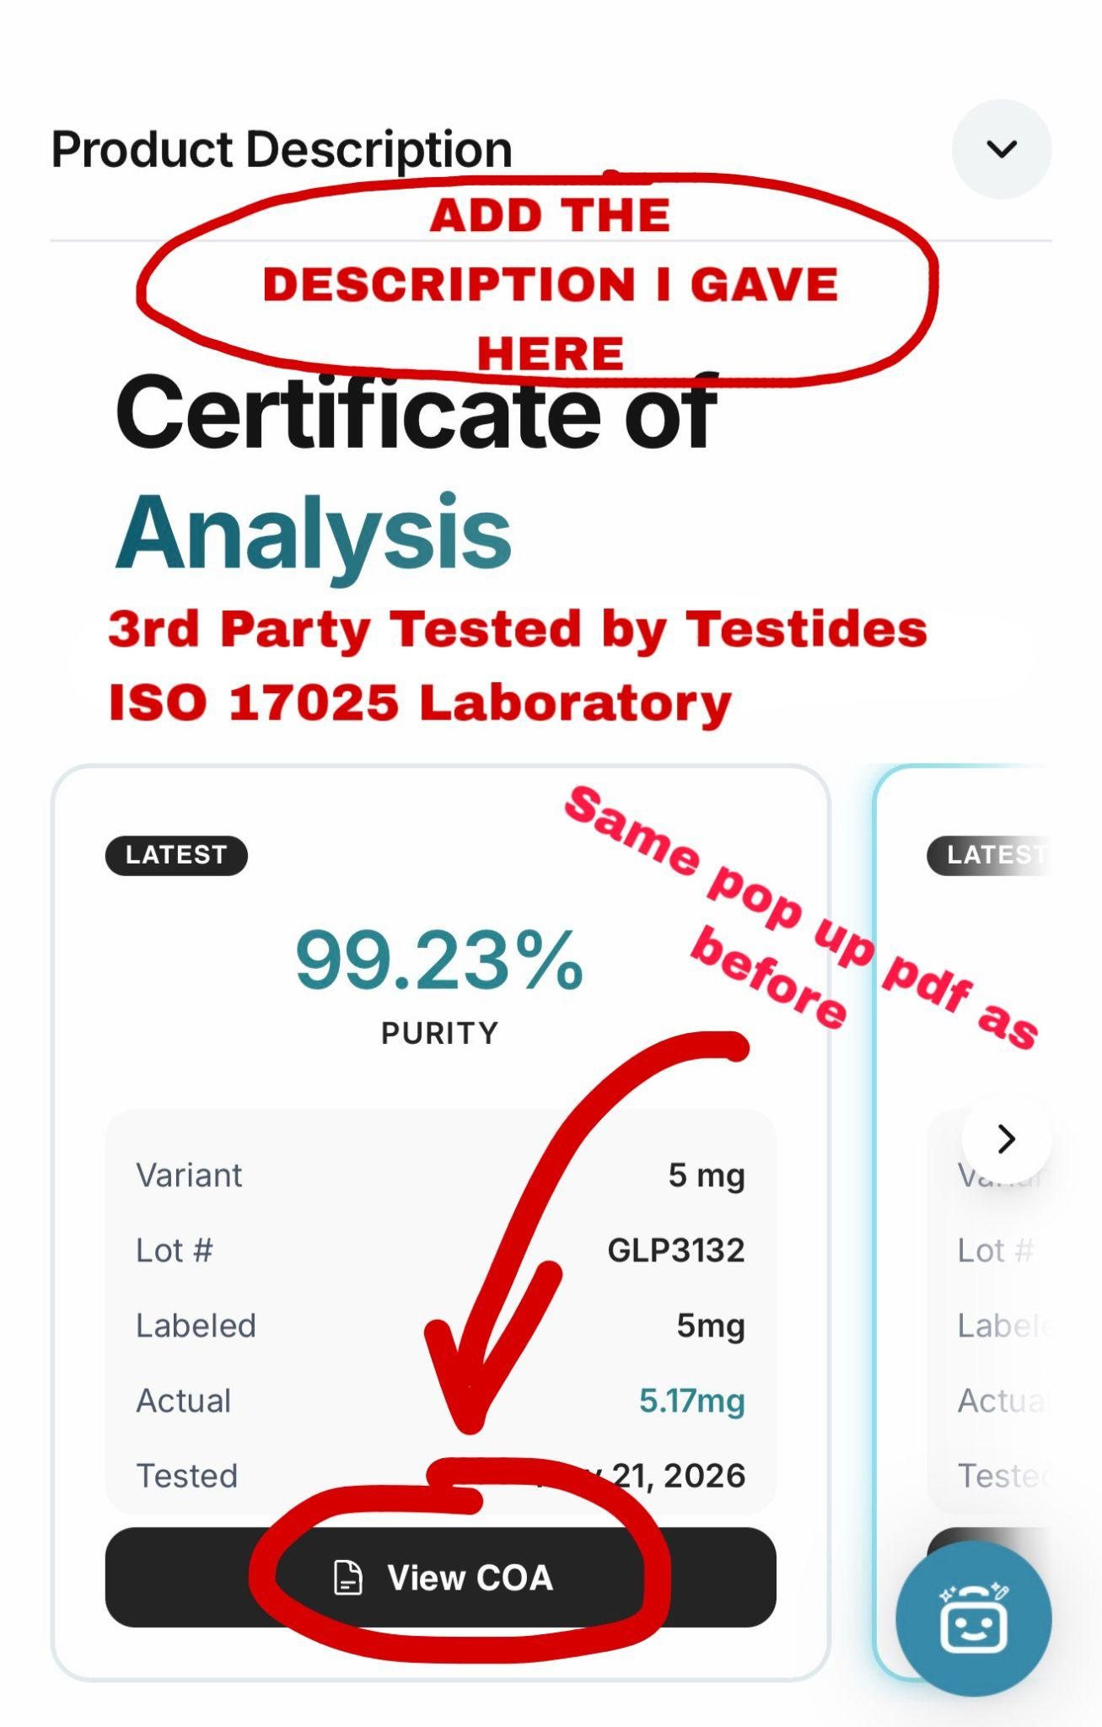

And this is how it should all look…
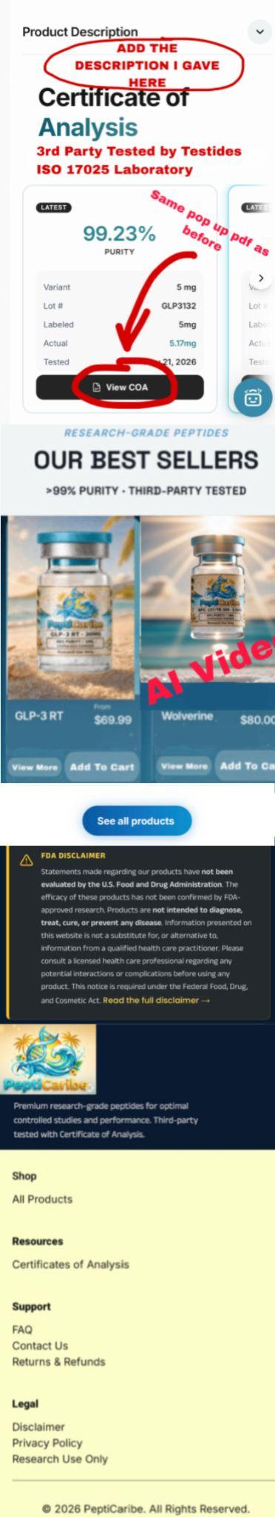

Shopping Cart Page (Once they add to cart)

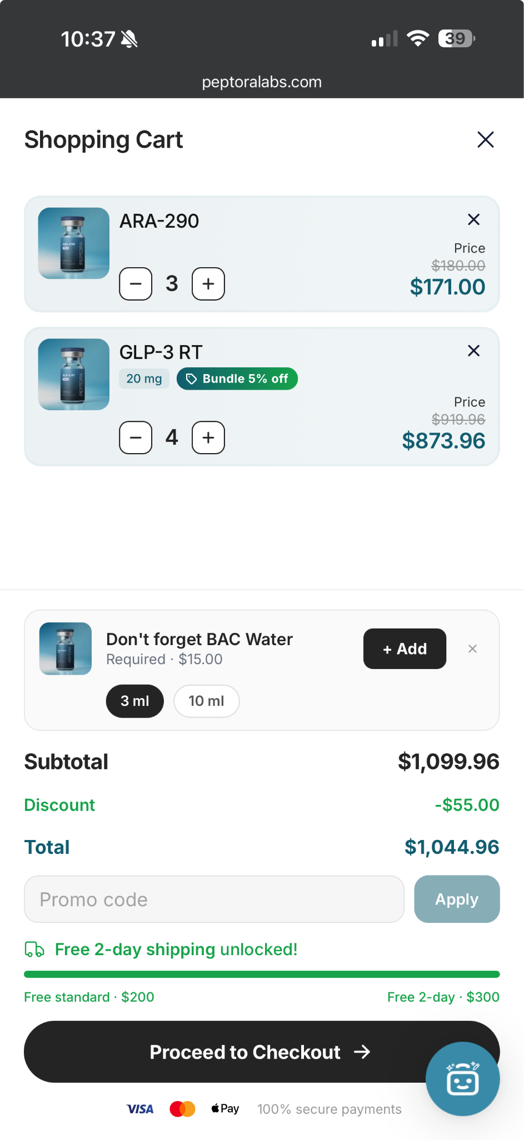
Certificate of Analysis Page…
Should have UI of this page; https://www.aminoclub.com/us/coa // Should have vial pics and then direct link of COA. Look at mockup below.
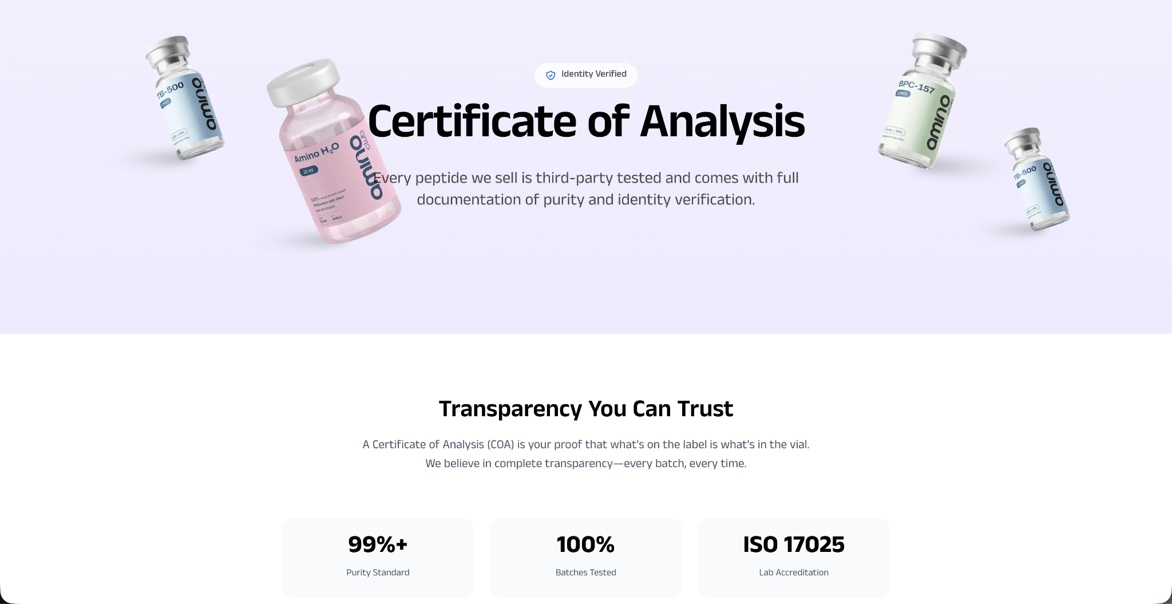

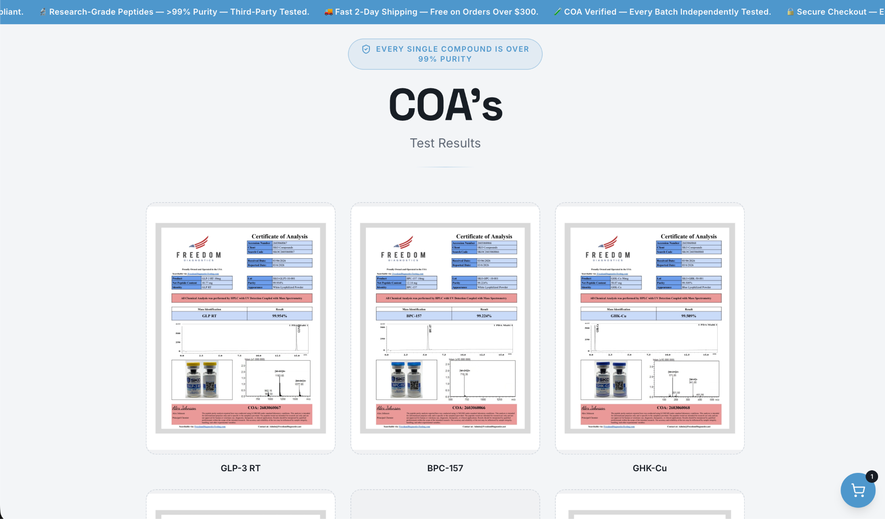
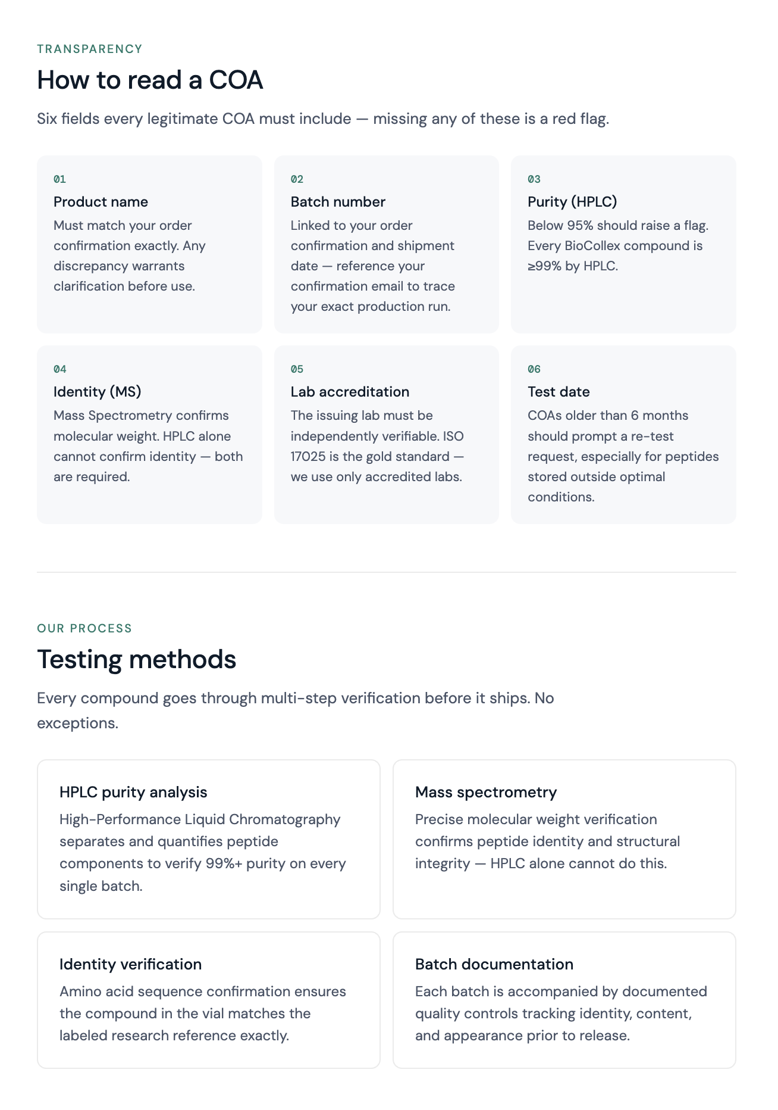

Footer
Shop
All Products

Resources
Certificates of Analysis

Support
FAQ
Contact Us
Returns & Refunds

Legal
Disclaimer
Privacy Policy
Research Use Only
Terms & Conditions
Return & Refund Policy

Footer Explanation of tabs
MOSTLY COPY & PASTE

Shop:
All Products
Links to the Product page

Resources:
Certificates of Analysis
Links to the Certificate of Analysis Page

Support:
FAQ:
https://www.aminoclub.com/us/faq does a decent job with maybe too many questions….

But main ones:
What are peptides and how do they work?
Peptides are short chains of amino acids that act as highly specific signaling molecules in biological systems. In research, they work by binding to targeted receptors to modulate cellular pathways, allowing scientists to study processes such as metabolism, tissue repair, and neurological function in laboratory models.
What is the intended use of your products?
All products sold by PeptiCaribe are intended strictly for Research Use Only (RUO). They are for in-vitro laboratory research, educational, and scientific purposes by qualified researchers and institutions only. Our peptides are not for human consumption, veterinary use, diagnostic purposes, or any therapeutic application. They have not been evaluated by the FDA for safety or efficacy in humans. By purchasing, you confirm you are using these compounds for legitimate laboratory research purposes only.
Quality & Testing - Are we third party tested?
Yes. All peptides undergo independent third-party testing to verify purity, identity, and quality. Certificates of Analysis from accredited ISO 17025 laboratories are available to confirm that each batch meets strict research-grade standards. All Certificates have tamper-evident results through digitally verifiable reporting. 8x testing is being implemented in our next batch of Certificates of Analysis. Our products are intended strictly for research use only.
How do I access the Certificate of Analysis (COA) for my order?
Every batch comes with a Certificate of Analysis from an accredited ISO 17025 laboratory. You can view or download COAs on our dedicated COA page. You can also request them anytime by emailing support with your order number. We are rolling out enhanced 8x testing standards on upcoming batches for additional verification.
How should I store and handle the peptides?
Store lyophilized peptides at –20°C for long-term stability or 2–8°C (refrigerated) for short-term use. Protect from light, moisture, and repeated freeze-thaw cycles. Once reconstituted, store in the refrigerator and use within the timeframe indicated on the product label or COA. Always follow standard laboratory handling protocols and wear appropriate personal protective equipment.
Ordering, Shipping & Payments - How long do products take to deliver
Products are shipped out the same day if placed before 4PM EST and are expected to arrive at your doorstep within 2-3 business days as 2-day shipping is included in every order.
What payment methods are accepted
We are currently accepting all major credit cards, Apple Pay, Google Pay, ACH Payments, Zelle. All transactions are processed through secure, encrypted payment gateways to protect your information.
Returns, Support & Wholesale - What is your return or replacement policy?
We stand behind every order. If your package arrives damaged, contact us within 48 hours with photos of the damaged items and packaging. We will review and, where appropriate, offer a one-time replacement. Reconstituted or opened products are not eligible for return. We do not offer refunds for change of mind. All shipments include protective packaging.
Do you offer bulk or wholesale pricing?
Yes. We offer competitive bulk and wholesale pricing for research institutions, universities, and high-volume customers. Email info@pepticaribe.com with your peptide requirements, quantities, and any recurring needs for a custom quote. Bulk orders may qualify for expedited processing and dedicated account support.

Contact Us
Page can be like this how the top of https://www.aminoclub.com/us/contact is but no need for another FAQ under that. For an “Email Us” display can be implemented, how https://www.peptoralabs.com/contact has it towards the bottom.

Legal:
Disclaimer
Amino does a good job fine with replication: https://www.aminoclub.com/us/disclaimer

Privacy Policy
Last Updated: June 3, 2026
PeptiCaribe is committed to protecting your privacy. This Privacy Policy explains how we collect, use, disclose, and safeguard your personal information when you visit our website at pepticaribe.com (the “Site”), place an order, or otherwise interact with us. All products offered on this Site are intended exclusively for legitimate in-vitro laboratory and scientific research purposes only.

1. Information We Collect
We collect information you provide directly to us and information collected automatically when you use our Site.
Information You Provide:
- Contact information (name, email address, phone number, shipping address, and billing address)
- Account information (username and securely hashed password, if you create an account)
- Order and transaction details (products purchased, order history)
- Communications you send us (support requests, emails, or messages)
Automatically Collected Information:
- IP address, browser type, device information, and operating system
- Pages viewed, time spent on the Site, and referring/exit pages
- Cookies and similar tracking technologies

2. Payment Processing
Payments are processed exclusively through trusted third-party payment processors. PeptiCaribe does not store or have direct access to full credit card numbers or banking details. All payment information is handled securely in accordance with PCI-DSS standards.

3. How We Use Your Information
We use the information we collect to:
- Process and fulfill your orders
- Provide order confirmations, shipping updates, and customer support
- Improve our website, products, and services
- Prevent fraud and enhance security
- Comply with legal and regulatory obligations
- Send promotional communications (email or SMS) only when you have explicitly opted in

4. Marketing Communications (Email & SMS)
We may send promotional emails or SMS messages (such as order updates, special offers, or research-related news) only with your explicit consent. You can opt in during checkout or account creation.
You may opt out at any time by:
- Replying “STOP” to any SMS message
- Clicking the unsubscribe link in any email
- Contacting us at info@pepticaribe.com
Standard message and data rates may apply. We do not share your phone number with third parties for their own marketing purposes.

5. Information Sharing and Disclosure
We do not sell, rent, or trade your personal information. We may share your information only when necessary with:
- Trusted service providers (payment processors, shipping carriers, email/SMS platforms, and analytics providers) who are contractually obligated to protect your data
- Law enforcement, regulatory authorities, or as required by applicable law
- Affiliated entities for internal operational purposes
- In the event of a merger, acquisition, or sale of assets (your information would be transferred under equivalent privacy protections)

6. Data Security
We implement industry-standard security measures, including encryption, secure server infrastructure, access controls, and regular monitoring, to protect your personal information. While we take reasonable steps to safeguard your data, no online system can be guaranteed to be 100% secure.

7. Cookies and Tracking Technologies
Our Site uses cookies and similar technologies to improve functionality, analyze usage, remember preferences, and enhance your experience. You can manage cookie preferences through your browser settings. Disabling cookies may affect certain features of the Site.

8. Your Privacy Rights
Depending on your jurisdiction, you may have the right to:
- Access the personal information we hold about you
- Request correction of inaccurate information
- Request deletion of your personal information
- Restrict or object to certain processing activities
- Opt out of marketing communications
- Request a portable copy of your data (where applicable)
To exercise these rights, please email us at info@pepticaribe.com. We will respond within the timeframes required by applicable law.

9. California Privacy Rights (CCPA/CPRA)
If you are a California resident, you have additional rights under the California Consumer Privacy Act (CCPA), including the right to know what personal information we collect, the right to delete your information, and the right to opt out of the sale of your information. PeptiCaribe does not sell personal information.

10. Children’s Privacy
Our Site and services are intended for individuals who are at least 21 years of age. We do not knowingly collect personal information from anyone under 21. If we become aware that we have collected information from a minor, we will promptly delete it.

11. Third-Party Links
Our Site may contain links to third-party websites. We are not responsible for the privacy practices or content of those sites. We encourage you to review their privacy policies before providing any personal information.

12. Changes to This Policy
We may update this Privacy Policy from time to time. We will notify you of any material changes by updating the “Last Updated” date on this page. Your continued use of the Site after changes are posted constitutes acceptance of the updated policy.

13. Contact Us
If you have any questions about this Privacy Policy or our privacy practices, please contact us:
PeptiCaribe
Email: info@pepticaribe.com
Website: https://www.pepticaribe.com
We appreciate your trust in PeptiCaribe for your laboratory research needs.

Research Use Only
Amino replication is nice: https://www.aminoclub.com/us/research-use

Terms & Conditions
Last Updated: June 3, 2026

Welcome to PeptiCaribe. By accessing or using our website at pepticaribe.com (the “Site”), placing an order, participating in the Affiliate Program, or otherwise interacting with PeptiCaribe, you agree to be fully bound by these Terms & Conditions (“Terms”). Please read them carefully. If you do not agree to any provision, you must immediately cease use of the Site, refrain from placing orders, and discontinue participation in the Affiliate Program.

1. Research Use Only – Important Disclaimer
All products sold by PeptiCaribe are intended strictly for legitimate in-vitro laboratory and scientific research purposes only. They are not intended, labeled, or approved for human consumption, injection, inhalation, animal or veterinary use, diagnostic, therapeutic, food, cosmetic, or any other non-research application. This restriction is absolute.

PeptiCaribe is not a registered 503A compounding pharmacy or 503B outsourcing facility. We do not compound, manufacture, dispense, or provide pharmaceutical-grade products or services for human or veterinary use. Any attempt to use our products for such purposes violates these Terms and may result in legal action.

Products may pose chemical, biological, or physical hazards if misused. They have not been evaluated by the U.S. Food and Drug Administration (FDA) for safety, efficacy, or any other purpose. PeptiCaribe makes no representations or warranties regarding the suitability of any product for a specific application.

By placing an order you represent and warrant that:
- You are at least 21 years of age (or the age of majority in your jurisdiction).
- You are a qualified researcher or authorized representative of a recognized research institution or laboratory.
- You possess the necessary expertise, facilities, licenses, and authorizations to safely handle, store, use, and dispose of research compounds.
- You will comply with all applicable local, state, federal, and international laws, including import/export regulations.
- You assume full responsibility and risk for any damages, injuries, or legal violations arising from the possession, handling, storage, use, or misuse of the products.
- You will not promote, imply, or suggest human or veterinary use in any communications or promotions.

2. Eligibility and Account Registration
Access to PeptiCaribe products and services is limited to qualified researchers, laboratory professionals, and organizations engaged in legitimate scientific research. PeptiCaribe reserves the right to approve, deny, or terminate any account or order at its sole discretion. We may request verification of research credentials or institutional affiliation at any time.

You are responsible for maintaining the confidentiality of your account credentials and for all activity under your account.

3. Orders and Payment
All orders are subject to acceptance and availability. PeptiCaribe reserves the right to accept, reject, modify, or cancel any order at any time for any reason, including suspected non-compliance with these Terms. By placing an order, you confirm that the purchase is solely for authorized research purposes.

Payments are processed securely through trusted third-party processors. We do not store complete credit card or banking information. Orders ship only after payment clears.

4. Shipping and Delivery
We offer same-day shipping for orders placed before 4:00 PM EST (subject to product availability). Delivery times are estimates only. PeptiCaribe is not liable for delays caused by carriers, customs, weather, or circumstances beyond our reasonable control. You are solely responsible for compliance with all import/export laws and local regulations in your jurisdiction.

Risk of loss and title pass to you upon delivery to the carrier.

5. Returns, Refunds, and Exchanges
All sales are final. Due to the specialized and sensitive nature of research-grade materials, PeptiCaribe does not accept returns, offer refunds, or provide exchanges.Reconstituted products are not eligible for replacement. Please refer to our separate Return & Refund Policy for full details.

6. Prohibited Conduct
You agree not to:
- Use products for any purpose other than legitimate in-vitro laboratory research.
- Promote, imply, suggest, or discuss human consumption, veterinary use, therapeutic benefits, dosing, or medical applications of any product.
- Resell products without prior written authorization.
- Use automated means to access or scrape the Site.
- Violate any applicable laws or regulations.
- Engage in any activity that could expose PeptiCaribe to regulatory, legal, or reputational risk.

Violation of these prohibitions may result in immediate account termination, order cancellation, forfeiture of any affiliate commissions, and a permanent ban from our services.

7. Assumption of Risk and Waiver
You expressly acknowledge and agree that your purchase, possession, handling, storage, and use of any products from PeptiCaribe is at your sole and exclusive risk. You voluntarily assume all risks associated with the products, including risks arising from improper storage, handling, contamination, degradation, misuse, or any application to humans or animals.

To the fullest extent permitted by law, you waive, release, and forever discharge PeptiCaribe, its officers, employees, affiliates, and agents from any and all claims, demands, actions, liabilities, damages, costs, and expenses (including attorneys’ fees) arising from or related to your possession, handling, storage, use, or misuse of the products.

8. Disclaimer of Warranties
All products and the Site are provided “AS IS” and “AS AVAILABLE” without warranties of any kind, express or implied. PeptiCaribe disclaims all warranties, including merchantability, fitness for a particular purpose, and non-infringement. We make no warranty that products will meet your specific research requirements or that Certificates of Analysis (COAs) guarantee fitness for any particular application.

9. Limitation of Liability
To the maximum extent permitted by law, PeptiCaribe and its officers, employees, affiliates, and agents shall not be liable for any indirect, incidental, special, consequential, exemplary, or punitive damages arising from or related to your use of the Site, purchase of products, or these Terms.

Our total aggregate liability shall not exceed the amount you paid for the specific product(s) giving rise to the claim.

10. Indemnification
You agree to indemnify, defend, and hold harmless PeptiCaribe, its officers, employees, affiliates, and agents from and against any and all claims, damages, losses, liabilities, costs, and expenses (including reasonable attorneys’ fees) arising out of or related to:
- Your use, misuse, or handling of products.
- Any statements, claims, or promotions you make regarding our products.
- Your violation of these Terms or applicable laws.
- Any regulatory action resulting from your actions or promotions.

11. Intellectual Property
All content on the Site is the property of PeptiCaribe or its licensors and is protected by intellectual property laws. You may not reproduce, modify, distribute, or create derivative works without prior written consent.

Approved affiliates receive a limited, revocable license to use approved promotional materials solely for participation in the Affiliate Program, provided all promotions strictly comply with research-use-only guidelines.

13. Termination
PeptiCaribe reserves the right to suspend or terminate your account, cancel orders, or end affiliate participation at any time, for any reason, at our sole discretion. Key provisions (including disclaimers, liability limitations, indemnification, and governing law) survive termination.

14. Dispute Resolution & Arbitration Any dispute, claim, or controversy arising out of or relating to these Terms, the Site, your use of the Site, or any products purchased from PeptiCaribe shall be resolved exclusively through binding arbitration administered by the American Arbitration Association (AAA) in accordance with its Commercial Arbitration Rules. The arbitration shall be conducted by a single arbitrator.
Arbitration shall take place in Miami, Florida (or another location mutually agreed upon by the parties). Arbitration shall be conducted on an individual basis only. You expressly waive any right to bring or participate in any class action, class arbitration, or representative proceeding. The arbitrator’s decision shall be final and binding, and judgment upon the award may be entered in any court having jurisdiction.
15. Governing Law These Terms and any dispute arising under or relating to them shall be governed by and construed in accordance with the laws of the State of Florida, without regard to its conflict of law principles.
Subject to the arbitration provision above, any legal action or proceeding permitted under these Terms shall be brought exclusively in the state or federal courts located in the State of Florida, and you consent to the personal jurisdiction of such courts.
16. Modifications to Terms
PeptiCaribe may update these Terms at any time. Changes are effective immediately upon posting. Your continued use of the Site constitutes acceptance of the updated Terms.

17. Force Majeure
PeptiCaribe shall not be liable for any failure or delay in performance due to causes beyond our reasonable control, including acts of God, natural disasters, war, government actions, labor disputes, or internet disruptions.

18. Severability, Waiver, and Entire Agreement
If any provision of these Terms is found to be invalid or unenforceable, the remaining provisions shall continue in full force. These Terms, together with our Privacy Policy and Return Policy, constitute the entire agreement between you and PeptiCaribe. They supersede all prior agreements and communications.

19. Contact Information
For questions regarding these Terms, please contact:

PeptiCaribe
Email: info@pepticaribe.com
Website: https://www.pepticaribe.com
We appreciate your trust in PeptiCaribe for your laboratory research needs.
Return & Refund Policy - PeptiCaribe
Last Updated: June 3, 2026
Due to the specialized and sensitive nature of our research-grade products, which are manufactured and sold strictly for legitimate laboratory and scientific research purposes, all sales are final. PeptiCaribe does not offer refunds, returns, or exchanges for any reason, including but not limited to change of mind, buyer’s remorse, incorrect product selection, misunderstanding of specifications, or failure to review product details prior to purchase.
Our products are high-purity research compounds that often require specific storage conditions and careful handling. Once an order has shipped, we are unable to accept returns because we cannot guarantee the integrity, stability, or proper storage of any product that has left our facility. This policy also protects the safety and compliance standards required for research materials.
Research Use Only (RUO) Disclaimer
All products sold by PeptiCaribe are intended solely for Research Use Only. They are not intended for human consumption, veterinary use, diagnostic purposes, therapeutic applications, or any other non-research purpose. These compounds have not been evaluated by the U.S. Food and Drug Administration (FDA) and are not approved for any medical use. PeptiCaribe is not a registered 503A compounding pharmacy or 503B outsourcing facility. By purchasing from us, you acknowledge and agree that you are a qualified researcher or institution and will use these products only in accordance with all applicable laws and regulations.
Customer Responsibilities
Customers are fully responsible for the proper receipt, storage, handling, reconstitution, and use of all products in compliance with local, state, and federal regulations. PeptiCaribe assumes no liability for any misuse, improper handling, or failure to follow recommended storage and safety protocols.
To help ensure a smooth purchasing experience, we strongly recommend that you carefully review all product descriptions, specifications, purity data, pricing, and shipping information before completing your order. If you have any questions or need clarification regarding a product, please contact us at info@pepticaribe.com prior to placing your order.
Thank you for choosing PeptiCaribe for your laboratory research needs. We appreciate your understanding of our policies, which are in place to maintain the highest standards of quality and regulatory compliance.

Site Product Descriptions & Pricing With Bundles
Bacteriostatic water is a sterile water solution containing 0.9% benzyl alcohol. It is intended for laboratory use as a solvent in the preparation and dilution of research peptide solutions, providing a microbial growth-inhibiting medium suitable for multi-dose applications.
BAC: 10ML - $10 // 30ML - $22
———
1. RETA:
GLP-3 is a triple agonist research peptide designed to engage GLP-1, GIP, and glucagon receptors simultaneously. Supplied in lyophilized form, this compound is prepared for laboratory reconstitution in preclinical studies exploring multi-receptor signaling dynamics and metabolic regulation pathways. Research Use Only.
Reta 10: $90 // Reta 20: $130 // Reta 30: $170
Bundles: 2Vials 5% off // 3 Vials 8% off // 4 Vials 10% off
———
2. T-2:
GLP-2 T is a synthetic dual incretin receptor agonist peptide supplied exclusively for laboratory and scientific research. In experimental models, it is examined for its interactions with metabolic signaling cascades and receptor-mediated regulatory systems under controlled conditions. Research Use Only.
T-2 30: $110 // T-2 60: $170
Bundles:
———
3. GHK-Cu:
Presented as a copper-bound tripeptide in lyophilized form, GHK-Cu is intended for laboratory preparation of solutions. Researchers investigate this compound in vitro for its participation in copper-dependent enzymatic processes, collagen synthesis pathways, and extracellular matrix remodeling. Research Use Only.
GHK-Cu 50: $35 // GHK-Cu 100: $45
Bundles:
———
4. BPC-157/TB-500:
This defined combination of TB500 and BPC-157 is formulated for laboratory exploration of coordinated tissue remodeling mechanisms and cytoskeletal reorganization. The blend is supplied in lyophilized powder form and is commonly studied in tissue model assays and cellular motility research. Research Use Only.
BPC/TB: $50
Bundles:
———
5. BPC-157:
BPC-157 is a synthetic pentadecapeptide supplied in lyophilized form for laboratory use. It is investigated in experimental models for its engagement with tissue protection pathways, angiogenic signaling networks, and inflammatory response modulation systems. Research Use Only.
BPC-157: $40
Bundles:
———
6. MOTS-c:
MOTS-c is a mitochondrial-derived research peptide provided in lyophilized form. This compound is reconstituted for laboratory studies focused on mitochondrial function, insulin signaling networks, and cellular metabolism regulation processes. Research Use Only.
MOTS-c: $50
Bundles:
———
7. ***CJC-1295/Ipamorelin:
CJC-1295/Ipamorelin is a synthetic research peptide combination prepared exclusively for laboratory and in vitro applications. It is studied in controlled research environments for its interactions with pulsatile growth hormone release pathways, metabolic signaling systems, and tissue recovery mechanisms. Research Use Only.
CJC-1295/Ipamorelin: $60
Bundles:
———
8. SS-31:
SS-31 is a synthetic mitochondria-targeting tetrapeptide developed solely for laboratory and scientific research. In experimental models, this compound is examined for its interactions with mitochondrial membrane dynamics, cellular energy systems, and oxidative stress-related pathways. Research Use Only.
SS-31: $50
Bundles:
———
9. KPV:
KPV is a synthetic tripeptide fragment of α-MSH supplied for laboratory research. It is investigated in experimental models for its interactions with inflammatory signaling cascades, melanocortin-associated regulatory mechanisms, and cellular immune modulation pathways. Research Use Only.
KPV: $50
Bundles:
———
10. NAD+:
NAD+ is a fundamental biological coenzyme central to cellular redox reactions and metabolic signaling. This compound is developed exclusively for laboratory and scientific research and is studied in experimental models for its role in energy metabolism pathways, mitochondrial function, and intracellular signaling networks. Research Use Only.
NAD+: $60
Bundles:
———
11. ***Glutathione:
Glutathione is an endogenous tripeptide antioxidant supplied in lyophilized form for laboratory preparation. Researchers examine this compound in experimental models for its involvement in cellular redox homeostasis, oxidative stress response pathways, and detoxification systems. Research Use Only.
Glutothione: $60
Bundles:
———
12. 5-Amino-1MQ:
5-Amino-1MQ is a synthetic small molecule research compound developed exclusively for laboratory and scientific research applications. It is studied in experimental models for its inhibitory activity on nicotinamide N-methyltransferase (NNMT) and its interactions with metabolic regulation pathways and cellular energy homeostasis. Research Use Only.
5-Amino-1MQ: $70
Bundles:
————————Below Are Products that will be Private till Obtained/launched——————————
13. Tesamorelin
Tesamorelin is a synthetic growth hormone-releasing hormone analog prepared exclusively for laboratory and scientific research. In experimental models, it is examined for its interactions with GHRH receptors, growth hormone secretion pathways, and metabolic regulation systems. Research Use Only.
Tesamorelin: $70
Bundles:
———
14. KLOW:
KLOW is a blended research peptide formulated strictly for in vitro and preclinical laboratory investigation. This mixture is studied for its engagement with tissue regeneration mechanisms and cellular signaling pathways in controlled research settings. Research Use Only.
KLOW: $100
Bundles:
———
15. Adamax:
Adamax is a synthetic peptide analog incorporating adamantane modifications and supplied exclusively for laboratory research. It is investigated in experimental models for its interactions with neurochemical signaling pathways, neuroprotective mechanisms, synaptic plasticity processes, and cognitive function research. Research Use Only.
Adamax: $70
Bundles:
———
16. Semax:
Semax is a synthetic peptide analog derived from adrenocorticotropic hormone (ACTH 4–10) and prepared for laboratory and scientific research. In research settings, this compound is studied for its interactions with neurochemical signaling pathways, cognitive-related mechanisms, and stress-response systems. Research Use Only.
Semax: $40
Bundles:
———
17. Selank:
Selank is a synthetic peptide analog derived from tuftsin and developed exclusively for laboratory and scientific research applications. It is examined in controlled environments for its interactions with neurochemical signaling systems, stress-response pathways, and neuroregulatory mechanisms. Research Use Only.
Selank: $40
Bundles:
———
18. Melanotan II:
Melanotan II is a synthetic cyclic heptapeptide melanocortin receptor agonist supplied for laboratory research. Researchers investigate this compound in experimental models for its interactions with melanocortin pathways, melanogenesis regulation mechanisms, and receptor-mediated signaling systems. Research Use Only.
Melanotan II: $40
Bundles:
———
19. DSIP:
DSIP is a synthetic neuropeptide developed exclusively for laboratory and scientific research applications. It is studied in experimental models for its interactions with sleep regulation pathways, stress-response neuroendocrine systems, and neurophysiological mechanisms. Research Use Only.
DSIP: $50
Bundles:
———
20. PT-141:
PT-141 is a synthetic melanocortin receptor agonist peptide prepared exclusively for laboratory and scientific research. In experimental models, it is examined for its interaction with central melanocortin pathways, neurochemical signaling systems, and receptor-mediated regulatory mechanisms. Research Use Only.
PT-141: $40
Bundles:
————————————————————————

